A000-Austria-Willendorf-Venus Figurine

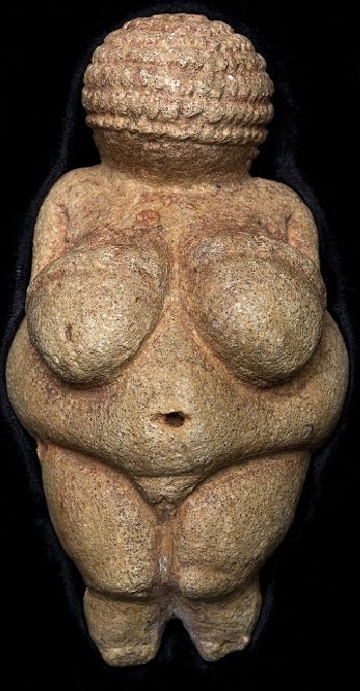

### The Venus of Willendorf in the box where it had found a home for the first 80 years after its discovery, now in the [Naturhistorisches Museum Wien](http://www.nhm-wien.ac.at/en)

Case no. 1

Formal Label: Austria-Venus of Willendorf, 29,500 BCE

Accession Number:

LC Classification:

Date or Time Horizon: 29,500 BCE

Geographical Area:

Cultural Affiliation: Gravettian or Upper Perigordian culture of the Upper Paleolithic

Media: yellowish limestone, tinted red by traces of ochre

Dimensions: H 11; W 4 cm

Weight:

Condition: the feet appear to be broken off

### Provenance: The Venus of Willendorf was discovered on August 7th, 1908, during excavation work carried out in Willendorf (World Heritage Region Wachau, Lower Austria) by the Imperial Natural History Museum Vienna by Austrian archaeologist Josef Szombathy during systematic investigations of the local Gravettian settlements in lower Austria, near Krems. Now, in the permanent collection of rock art in the [Naturhistorisches Museum, Wien](http://www.nhm-wien.ac.at/en).

Discussion:

The Venus of Willendorf is among the most famous archeological finds in the world. It depicts a severely overweight female figure with pendulous breasts, an obese middle and belly, pronounced buttocks, a belly button and vulva, and the only article of clothing is a braided net that almost totally covers the head and therefore there is no facial detail. If the artist worked from a model, corpulence is presumed rare in a period when food was scarce and so for reasons to protect childbirth in this challenging climate this individual was deemed worth ritualizing as a symbol of a successful fertility strategy.

The Venus of Willendorf was created during the same period as several other famous Stone Age figurines, and they perhaps were created also to ritualize a successful fertility strategy. Perhaps the following Gravettian or Upper Perigordian female figurines of the Upper Paleolithic were intended to ritualize a successful fertility strategy also. They

include the bas-relief Venus of Laussel (France), the ceramic Venus of Dolni Vestonice (Czech Republic), the ivory Venus of Lespugue (France), the steatite [Venus of Savignano](http://www.visual-arts-cork.com/prehistoric/savignano-venus.htm) (Italy), the stone [Venus of Gagarino](http://www.visual-arts-cork.com/prehistoric/gagarino-venus.htm) (Russia), as well as the Russian ivory figurines, known as the [Avdeevo Venuses](http://www.visual-arts-cork.com/prehistoric/avdeevo-venuses.htm), the [Venus of Kostenky](http://www.visual-arts-cork.com/prehistoric/venus-of-kostenky.htm), the [Mal'ta Venuses](http://www.visual-arts-cork.com/prehistoric/malta-venuses.htm) and the [Zaraysk Venuses](http://www.visual-arts-cork.com/prehistoric/zaraysk-venuses.htm).

References: